# Bulls and Cows

*In this exercise we are going to create a very popular game called "bulls and cows". You can read more information about the game and how it is played here:* [*https://en.wikipedia.org/wiki/Bulls_and_Cows*](https://en.wikipedia.org/wiki/Bulls_and_Cows)

## The game function

We are going to create all of our logic in a function called game. The purpose of this is for us to be able to start a game by passing it how many digits we have to guess. At the end, we should be able to start a game using the following lines of code: **"game(4)" / "game(5)"**

## Creating a random number

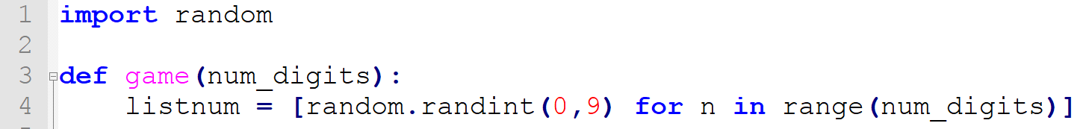

* Let us start by creating the game function. It should receive the number of digits that we want to guess.
* Then, we want to create the number that we want to guess. Since we want it to be random, we import the random library and use it to generate our number (as a list)

## Infinite while loop

The next thing that we will do is to create a while loop for the user to be able to write his guess.

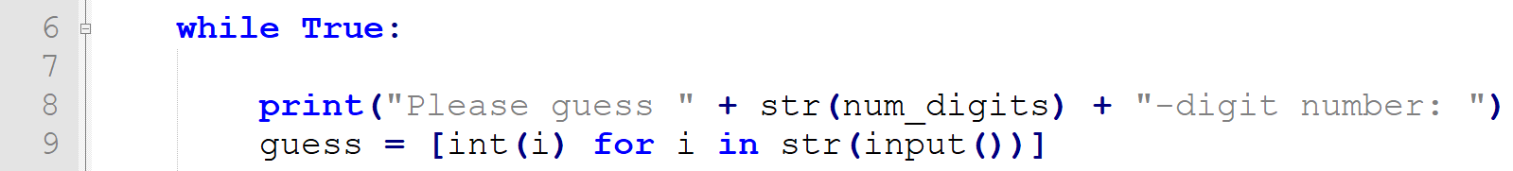

* We create a list with the guess of the user
* The next step is to calculate how many bulls and cows he has

## Calculating the bulls and cows

Now we are going to make several checks. The first would be to see if the guess of the user is correct

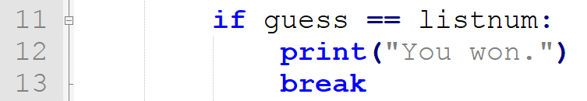

In any other case, we want to check how many bulls and cows the user has

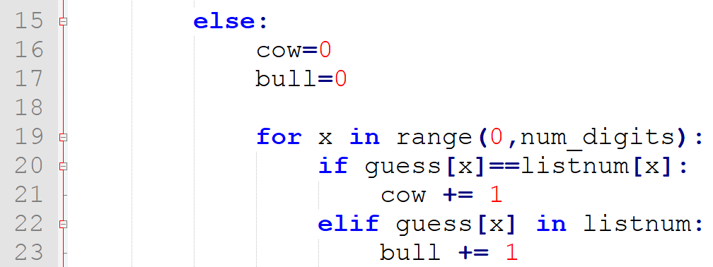

Finally, we want to print whose bulls and cows and ask the user to guess again



## Calculating the guesses of the User

Before testing our game, we want to calculate the count of guesses that the user makes and when he has guessed the number we want to congratulate him

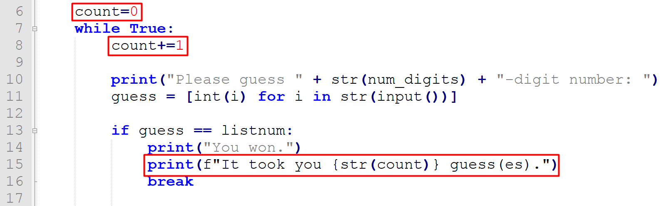

## Giving up

Now let us give the user a chance to give up and see the number. To do that, we need to make some changes to our code

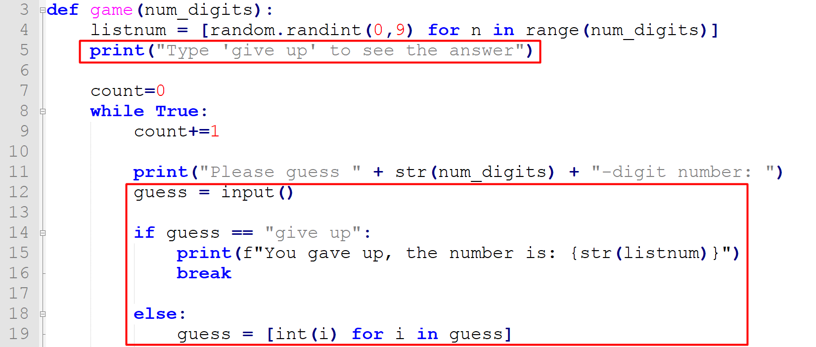

## Testing the code

Now try to play the game and see the result ☺